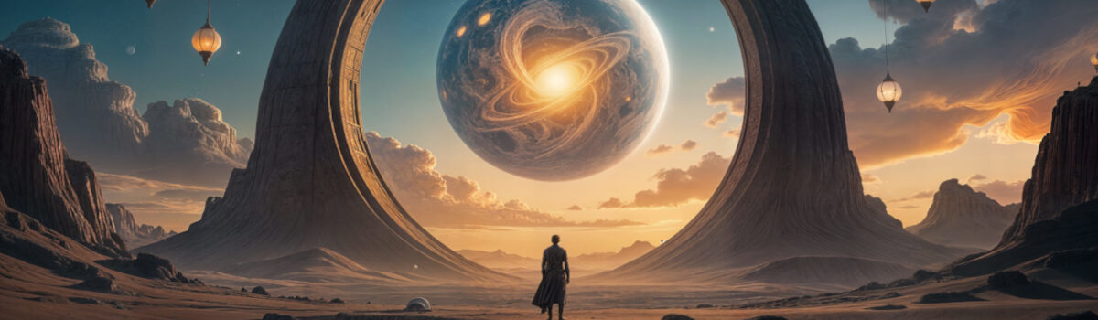
ELECTRONIC SURREALISM: WHERE DREAMS MEET ELECTRONIC MUSIC

THE MANIFESTO

We assume that this musical style has never been clearly identified other than by the generic term “electronic music.” However, this term now encompasses genres that are often very distinct. Electronic Surrealism allows us to establish a more precise definition, especially since it is still relevant throughout the world.
This new musical genre is completely free. It does not belong to any existing entity. Every artist, whether professional or passionate amateur, can identify with the culture of electronic surrealism if they wish. It is not necessary to accompany the music with surrealist visual representations, as synthesizers and other electronic instruments can generate surrealist sounds.
We, artists and explorers of Electronic Surrealism, affirm that music can transcend the boundaries of reality.
We believe that sound, when free and poetic, can reveal the invisible, stir the unconscious, and open doors to impossible worlds.
lectronic Surrealism is not just a musical style: it is an experience, an inner journey where electronics meet dreams, where machines become instruments of fantasy, and where each sound vibration becomes a color, a reflection, an emotion.
We affirm that:
The imagination is the master of sound. Every note, every texture, every silence must nourish the mind and inspire wonder.
Creative freedom is essential. We reject standardized constraints and seek to transcend conventions in order to invent new soundscapes.
The visual and the auditory merge. The musical experience is accompanied by images, shapes, and movements that prolong the dream, explore the incongruous, and magnify the unexpected.
Surrealism is a path, not a fixed style. It is not about reproducing the past, but about opening up new perspectives, surprising, disturbing, and enchanting.
The listener becomes a traveler. The music speaks to those who are willing to lose themselves, to dream, to feel what words cannot express.
Electronic Surrealism is a manifesto for the free spirit, an invitation to listen beyond the known, to feel the invisible, and to contemplate the unexpected.
We create soundscapes where one can daydream and where electronics become a brush for painting infinity.
December 2025 - Xhenon

